### [**Super Pi Day Ball**](https://papercraftetc.blogspot.com/2015/03/super-pi-day-ball.html)

Super Pi Day is coming! 3.14.15 is a once in a century event.

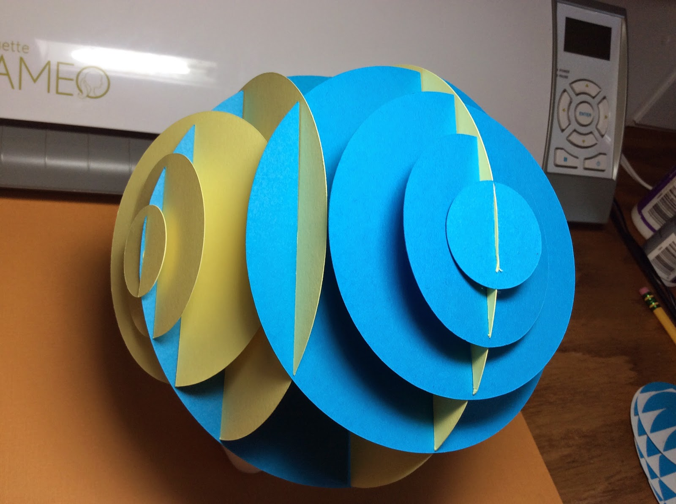

Pi Ball with different diameters of Pi

In honor of Super Pi Day, I decided to make a sliceform which represents the values of pi. I created the five circles with multiples of 3.14. The diameters starting at the smallest circle is 3.14 cm, 6.28 cm, 9.42 cm, 12.57 cm and 15.71cm respectively. I then placed the diameter of each of the four smaller circles on the edge of the largest circle at its midpoint to create a slit so that this sliceform could be created.

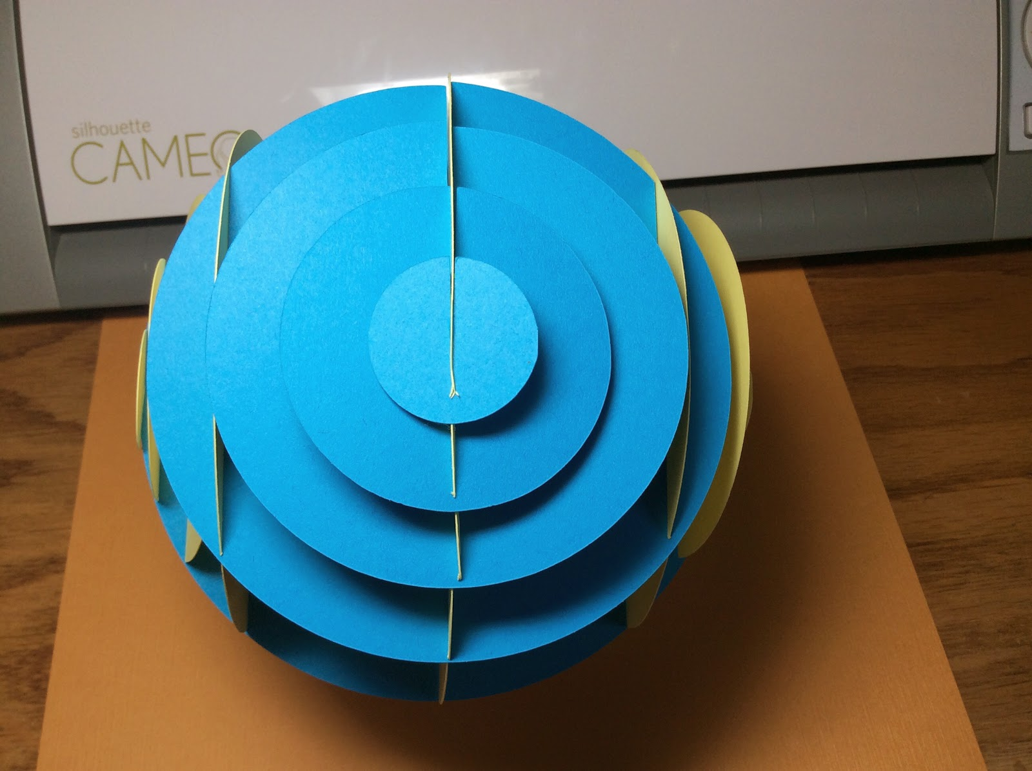  
  
Looking at it head on when the sliceform is a sphere, starting from the smallest circle and going inwards, you can visually see the increase in values of pi from 1 pi to 5 pi.

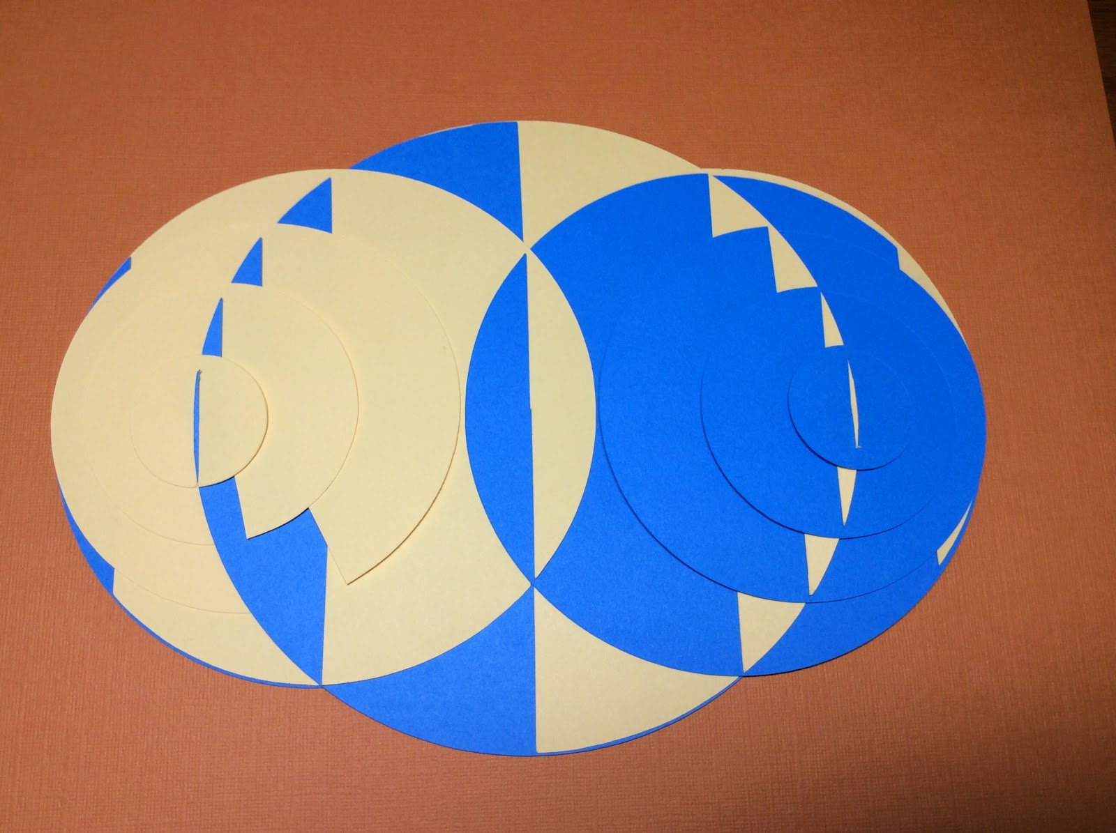  
  
Laying the sliceform down, the center is the largest circle of 5 pi and the other circles are skewed closer to the edge.

I made a sphere sliceform here. <http://papercraftetc.blogspot.com/2013/07/sliceforms-are-my-new-obsession.html> I love the visual differences of the two sliceforms.

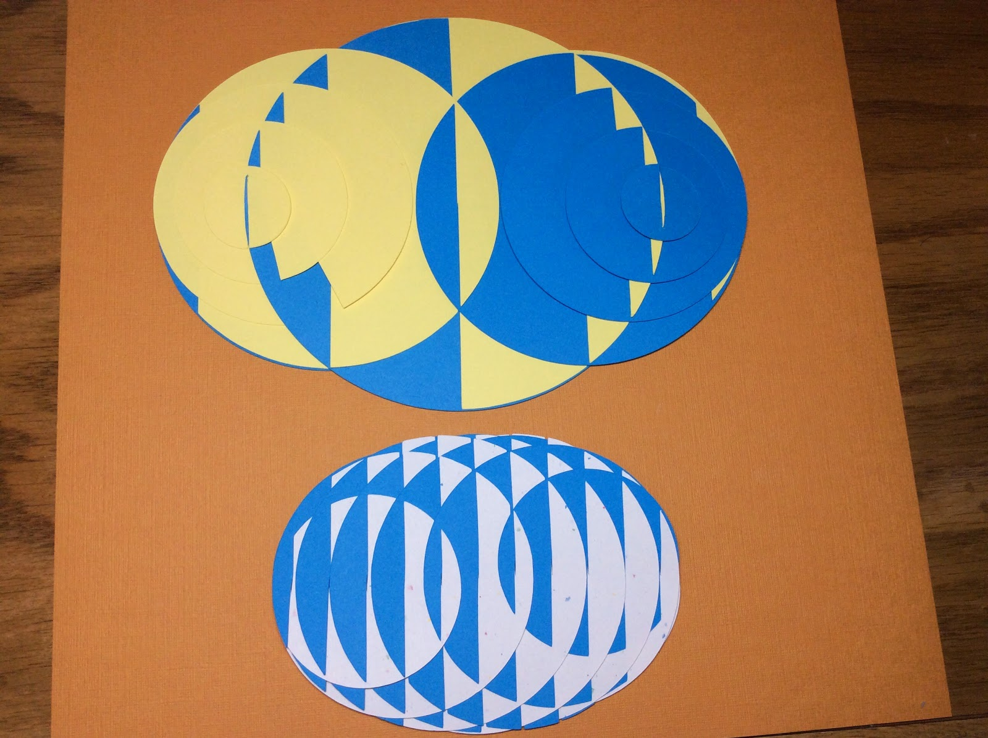

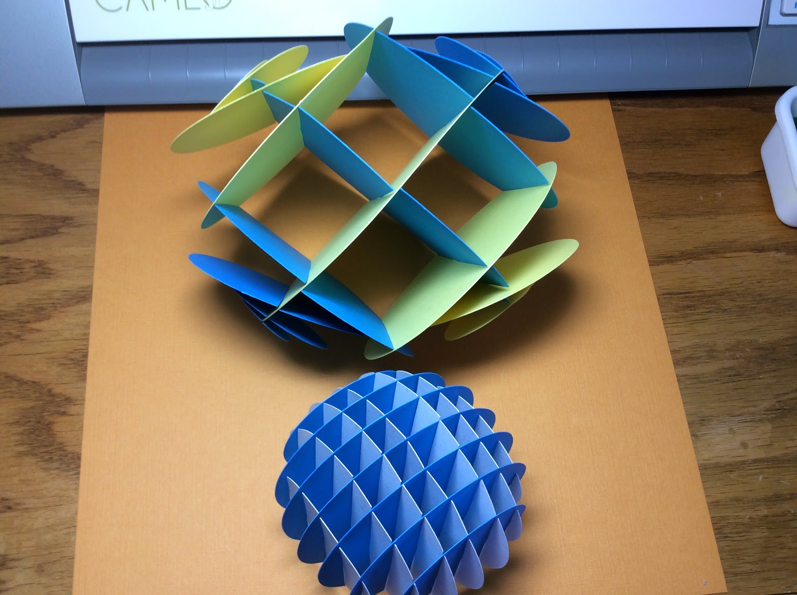

Poor Pi Ball does not have as much structure as a regular sphere sliceform. The slices are not at fixed intervals but at a multiple of pi.

Happy Super Pi Day!